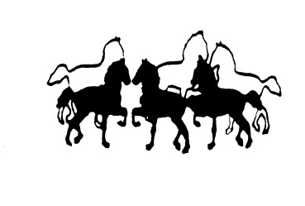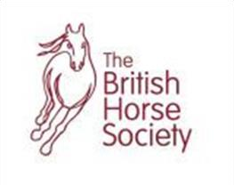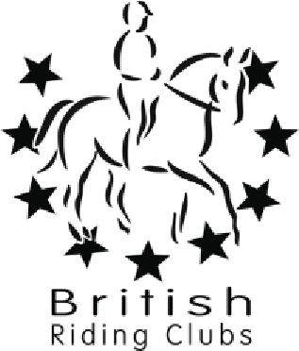

North Mymms Riding Club

Website : www.north
-
mymms
-
riding
-
club.co.uk

Affiliated To The BHS

Jumping Clinic with Kelly Crawley
At Ashendene Stud
White Stubbs Lane
Bayford SG13 8PZ

Sunday 10th July from midday.

Private (35 minutes) £32 per member, £35 per non-member
Semi private 2 (45minutes) £27 per member, £30 per non-member
Groups 3+ (60minutes) £22 per member, £25 per non-member

Chance to practice over jumps and venue where show jumping league being held.

When booking please select the level you are working towards.
Please select correct height for your ability. X-poles, 60cms,70cms,80cms,90cms.

Booking via:

https://www.myridinglife.com

Please check Facebook Page, Website & your e-mails for upcoming clinics.

All enquiries - phone Liz Kyriacos 07751445097 or email elizabethkyriacos@hotmail.co.uk

